# GRAPH

**VAR MODEL**

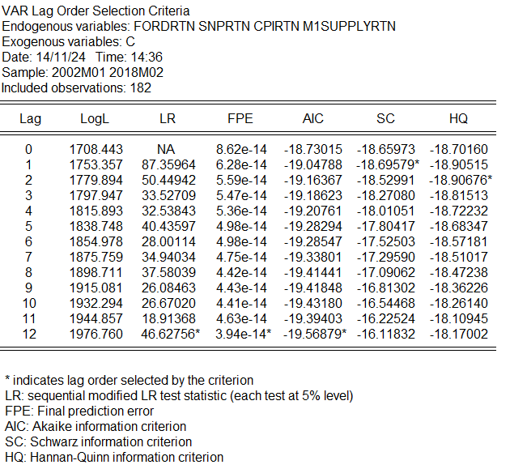***Lag selection:***

In the lag length criteria, I have employed various lag on the test. The value of AIC keeps falling with the increase of lag, thus, the AIC is not a reliable measure for this test. However, since AIC shows significant result at lag 12 for different lag test, we will keep in consideration. FPE may show significant in lag 12, however, FPE is mainly used for relatively small (<60 samples). HQC is the best indicator with relatively large sample size (>120) (Liew, 2004). Thus, we choose to test at lag 1,2 and 12 for our VAR model because the HQ value is significant at this lag.

**VAR(1) MODEL**

**VAR(2) MODEL**

**VAR(12) MODEL**

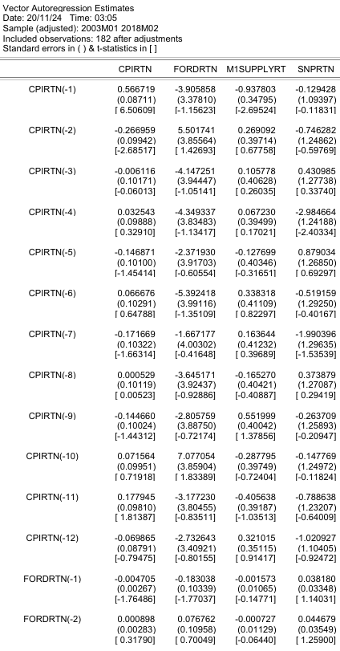

**DIAGNOSTIC TEST**

1. ***LM TEST (SERIAL CORRELATION)***

VAR(1) Lag 12

VAR(2) Lag 12

VAR(3) Lag 12

VAR(4) lag 12

VAR(5) lag 12

For every VAR model that is tested, we reject null hypothesis at certain lag (p-value <0.05). Thus, there is significant autocorrelation at certain lag. To fix autocorrelation issue, we try to input additional lag up to VAR(5). However, even when we increase the lag value, the model still suffers from autocorrelation issue. Thus, we will try the diagnostic test for VAR(12) model (choose based on AIC).

From the test, the p-values for all lag are greater than 0.05, thus, we fail to reject null hypothesis. Therefore, there is no serial autocorrelation at all lag for VAR(12) model. However, VAR(12) might overfit due to high number of lag. Thus, we stick to VAR(2) model even with autocorrelation problem because of parsimonious and easier to interpret.

1. ***WHITE TEST (HETEROSCEDASTICITY) [VAR(2)]***

Probability =0.000 (<0.05), we reject null hypothesis. Therefore, model suffers from heteroscedasticity. However, since we want to study dynamic relationships between variables rather than time-varying volatility, VAR model should be sufficient.

**GRANGER – CAUSALITY TEST [VAR (2)]**

SNP500 Return significantly Granger-causes CPI Return at 5% level, thus, changes in SNP500 Return may predict change in CPI Return. Other variables DO NOT significantly Granger-causes CPI Return at the 10% level. The joint test suggests that all variables together DO NOT predict CPI Return.

SNP500 Return significantly Granger-causes FORD Return at 1% level, thus, changes in SNP500 Return may predict change in FORD Return. Other variables significantly DO NOT Granger-causes FORD Return at the 10% level. The joint test suggests that all variables together predict FORD Return at 5% level.

CPI Return significantly Granger-causes M1 Money Supply Return at 1% level, thus, changes in CPI Return may predict change in M1 Money Supply Return. Other variables significantly DO NOT Granger-causes M1 Money Supply Return at the 10% level. The joint test suggests that all variables together predict M1 Money Supply Return at 1% level.

None of the variables significantly Granger-causes SNP500 Return at the 10% level. The joint test suggests that all variables together DO NOT predict SNP500 Return at 10% level.

Figure 1

SNPRTN

FORDRTN

CPIRTN

M1SUPPLYRTN

**IMPULSE RESPONSE FUNCTION**

From the Granger-causality test, there are certain contradiction in theory and the result of the test. From the Granger-causality test, relationship based on Figure 1 is shown. However, FORD Return is supposedly to affect SNP500 Return since it is part of the SNP500. Additionally, M1 Money Supply also should affect SNP500 Return (theoretically). Therefore, we choose to use Generalised Impulse Response Function (GIRF) instead of Orthogonalized Impulse Response Function (Cholesky Decomposition). This is mainly because GIRF does not impose strict ordering on variables (Figure 1 order cannot be justified with theory), thus, making GIRF more robust and reliable.

The most substantial and immediate impact on CPIRTN comes from its own shock, however, fade as period increases. This indicates the effect of shock is temporary. Shocks from other variables are insignificant and highly negligible as their responses are near zero with higher relative standard error. This indicates CPIRTN is primarily influenced by its own shocks rather than by shocks in the other variables. Overall, the responses suggest that CPIRTN is largely independent of the other variables in this system in terms of response to shocks over time.

Self-shock in FORDRTN have the strongest and most immediate impact (period 1), but this effect diminishes quickly. It is followed by the shock from SNPRTN which has positive short-term effect on FRDRTN. This lines up with theoretical expectations, as broader market movements often influence individual stock return. Shocks from CPIRTN and M1SUPPLYRTN are insignificant and highly negligible as their responses are near zero with higher relative standard error. Overall, the pattern suggests that FORDRTN is more influenced by its own shocks and by market-wide movements (proxied by SNPRTN), with minimal sensitivity to changes in M1SUPPLYRTN or CPIRTN.

M1SUPPLYRTN exhibits strong response to its own shock, however, its effects diminish quickly. CPIRTN has small and short-term impact on M1SUPPLYRTN. FORDRTN and SMPRTN have negligible effects with responses fluctuating near zero and shows no clear pattern. M1 supply is largely determined by monetary policy and macroeconomic factors, so the weak response to FORDRTN and SNPRTN are consistent with theory expectations. CPI’s short term effect may reflect monetary adjustment that is related to inflation.

SNPRTN is primarily influenced by its own shocks in the short term, with a significant response in the first period that decreases rapidly over time. FORDRTN has a noticeable but short-lived impact on SNPRTN, suggesting some relationships between then, however, the influence fades quickly. M1SUPPLYRTN and CPIRTN have minimal effects on SNPRTN, indicating change in M1 money supply and CPI do not significantly influence SNP500 return in this system.

Overall, in this system, financial returns (FORDRTN and SNPRTN) are more interrelated with each other than with macroeconomic indicators (M1SUPPLYRTN and CPIRTN), which mostly affect their own future values. The interaction between Ford and S&P 500 returns are short-lived and macroeconomic variables play a minimal role in influencing these returns.

**VARIANCE DECOMPOSITION**

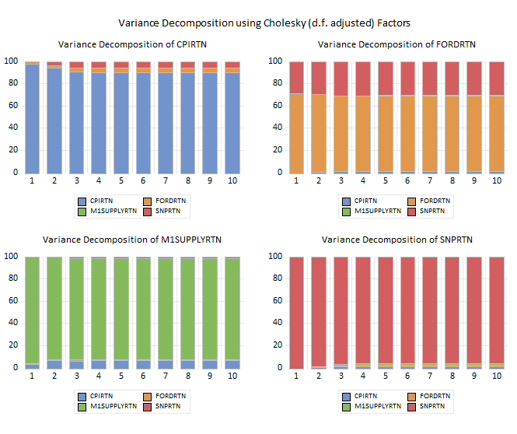

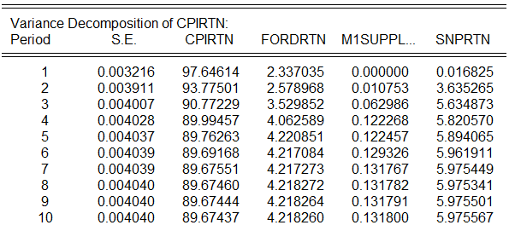

CPIRTN has most of its forecast error variance explained by its own shock initially. However, this self-influence shock decreases over time. FORDRTN and SNPRTN affect CPIRTN minimally over period of time.

The majority of FORDRTN forecast error variance is explained by its own shock. SNPRTN contribute significantly towards FORDRTN variance over time, reflecting a growing influence from this variable. This indicates dynamic relationship where the broader market influences individual stock market as time progresses.

M1SUPPLYRTN variance is dominated by its own shock, with over 90% of the entire forecast variance explained by itself across all periods. CPIRTN contribute quite significantly which grows over time, indicating shock from CPI start to impact money supply variance as period increases. There is minimal effect from FORDRTN and SNPRTN shocks toward money supply variance.

The variance of SNPRTN is largely self-explanatory, with over 95% of its forecast error variance explained by its own shock throughout the 10 periods. Other variables contribute minimally to SNPRTN’s forecast error variance, thus, SNPRTN relatively independent of shocks from other variables in the system.